**Cars Conjoint Analysis**

**Introduction**

Conjoint analysis is a powerful market research technique used to understand consumer preferences and decision-making processes. In this study, we will apply conjoint analysis to the automotive industry, specifically focusing on three well-known car brands: Ferrari, Lamborghini, and Lexus. By examining various attributes such as brand name, exterior design features, price tags, torque power, and car features, we aim to gain valuable insights into consumers' preferences when it comes to purchasing cars.

The three brand names included in this analysis, Ferrari, Lamborghini, and Lexus, represent different segments of the automotive market, each with its unique characteristics and brand image. Ferrari is renowned for its high-performance sports cars, Lamborghini is known for its extravagant and exotic designs, while Lexus is recognized for its luxury and refinement.

We will also explore two exterior design features that are often sought after by car enthusiasts: sleek and aerodynamic design, and sculpted body panels. These attributes contribute to the overall aesthetics of a car and can influence consumer preferences.

Price is a crucial factor when making a car purchase decision. In this analysis, we will consider three price tags: $70,000, $60,000, and $45,000. These price points represent different market segments and are indicative of the various options available to consumers at different budget levels.

Another significant aspect of a car's performance is its torque power, which determines the vehicle's acceleration and overall power output. We will examine two torque power levels: 8,400 RPM and 6,500 RPM. These levels represent different performance capabilities and can impact the driving experience.

Lastly, we will evaluate three car features: antilock braking system, airbags, and advanced driver assistance system. These features are essential for safety and convenience and are commonly sought after by car buyers.

By conducting conjoint analysis on these various attributes, we will uncover the relative importance of each attribute and how they interact with each other. The insights gained from this analysis will provide valuable guidance to car manufacturers and marketers in understanding consumer preferences and designing cars that align with customer expectations.

**Inputs**

In this conjoint analysis study, we collected inputs from 30 customers who evaluated 53 different profiles, each representing a combination of attributes related to cars. Among these profiles, four were designated as holdout cases, providing a benchmark for validating the accuracy of the analysis.

The attributes considered in this study include brand, exterior design type, price, torque power, and car features.

The gathered data, consisting of customer preferences on an ordinal scale, will be used to analyze the relative importance of each attribute and the interaction between them. By applying appropriate statistical techniques, we will gain insights into customers' preferences, helping car manufacturers understand the drivers behind consumer choices and make informed decisions regarding product design, pricing, and feature inclusion.

The holdout cases will serve as a validation set, allowing us to assess the accuracy and predictive power of the conjoint analysis model. The analysis results will provide actionable recommendations for car manufacturers to tailor their offerings to meet customer preferences and maximize market success.

**Syntax**

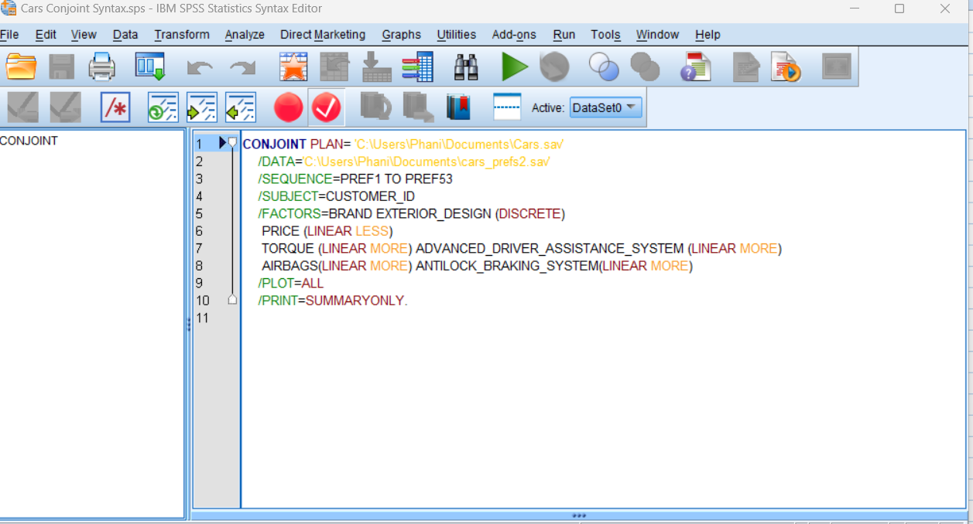

In the above syntax we can see that the factors brand and exterior design are “discrete” because they have discrete values like car brand names and exterior design type names like Lamborghini and sleek and aerodynamic. We can see than price have “linear less” because customer prefer less price. Other factors like torque, advanced driver assistance system, antilock braking system and airbags have “linear more” because they are preferred more by customers as there are safety features like airbags and antilock braking system plus assistance systems are preferred more because of the privilege’s they provide. We can also see that torque is “linear more” because the more torque power the better the performance.

**Profiles**

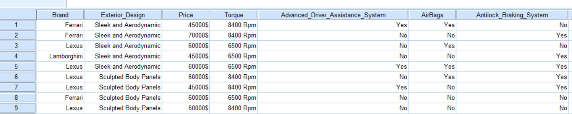

The above we can see different profiles and for each profile there will be a different utility value or same based on that the preference is decided that which combination of factors with their assigned levels are preferred by the customers and based on this insights can be gained into customer preferences and based on that business can improve their strategies.

**Output**

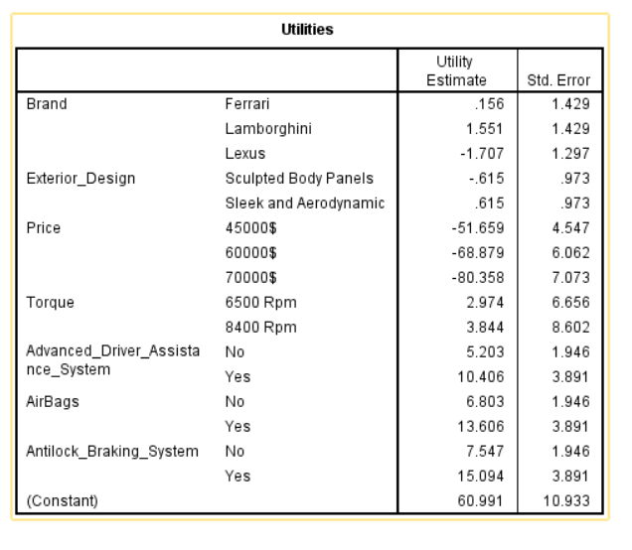

Based on utility values, Lamborghini has the highest preference with a value of 1.551. Sleek and aerodynamic design has a utility value of 0.615, $45,000 is preferred with a utility value of -51.659, 8,400 RPM torque power has a value of 3.844, and customers highly value features such as advanced driver assistance system (10.406), airbags (13.606), and antilock braking system (15.094). based on the utility values we can say these are most preferred by customers.

We can also calculate total utility values for each profile and based on the total utility values we can assign preferences. Let’s take two profiles for example like the above profiles image.

First profile which is Ferrari, sleek and aerodynamic,45000$,8400Rpm, Yes, Yes, No

We know the utility values for all these, and the constant value given in the output

Ferrari (0.156)+sleek&aerodynamic(0.615)+45000$(-51.659)+8400Rpm(3.844)+Yes(10.406)+Yes(13.606)+(7.547)+60.991. here the yes and no values are for car features like advanced driver assistance systems and airbags.60.991 is constant.

Ferrari (0.156)+sleek & aerodynamic(0.615)+45000$

(-51.659)+8400Rpm(3.844)+Yes(10.406)+Yes(13.606)+(7.547) +60.991(constant) = 45.506

Let’s take one more combination which is Lexus, sculpted body panels, 60000$, 8400Rpm, No, No, No

Lets calculate total utility which is -1.707+(-0.615)+(-68.879)+(3.844)+5.203+6.803+7.547+60.991 = 13.187

We can see that this combination has a lower utility value than the previous one

Which is 13.187<45.506 and this case Ferrari, sleek and aerodynamic,45000$,8400Rpm,Yes,Yes,No combination is most preferred one due to higher utility value based on customer preferences. In this way we can calculate utility values for each profile and preference 1 is given to highest total utility value profile and business organisations can use that profile in decision making and business strategies.

From the above importance values we can see price is most important in terms of importance values.

In correlations between observed and estimated preferences we can see perason’s R is 0.898 which is a good correlation

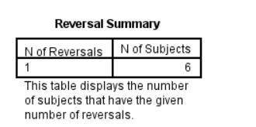

In terms of no of reversals we can see that 6 subjects have done it for torque where they have preferred less which is 6500 rpm than more

**Plots**

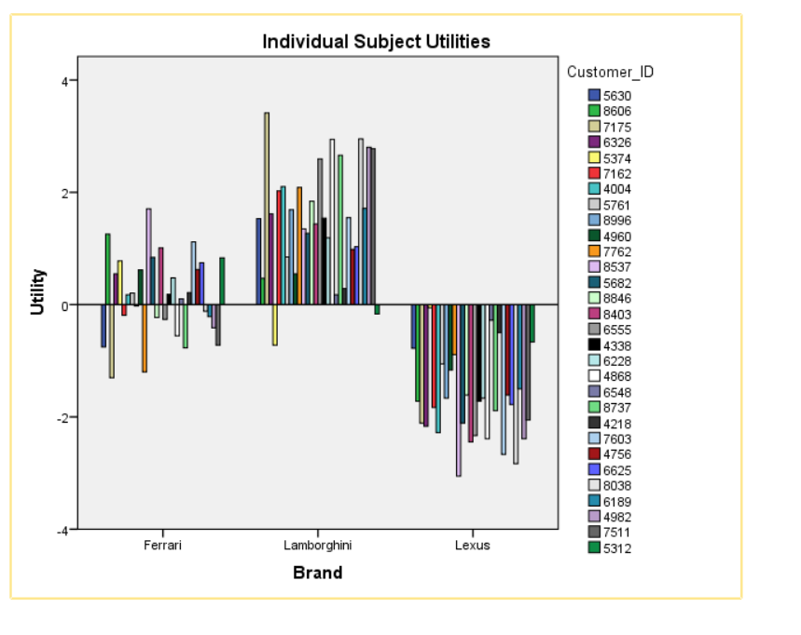

In the above plot we can see Lamborghini brand is most preferred by customers

In the above plot we can see that sleek and aerodynamic exterior design is most preferred by customers